Experiment 7

Code:

class Test

{

int a, b;

Test(int a, int b)

{

this.a = a;

this.b = b;

}

public static Test func(Test o)

{

o.a \*= 2;

o.b += 4;

return o;

}

public static void main(String args[])

{

Test ob = new Test(2, 3);

Test ob1 = new Test(0, 0);

System.out.println("Object's attributes before calling function: ob. a = " + ob.a + " and ob.b = " + ob.b);

ob1 = ob.func(ob);

System.out.println("Object's attributes after calling function: ob. a = " + ob.a + " and ob.b = " + ob.b);

System.out.println("Object's attributes after calling function: ob1. a = " + ob1.a + " and ob1.b = " + ob1.b);

}

}

Output:

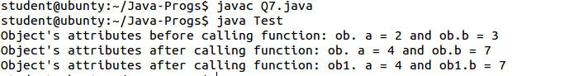

Experiment 6

Code:

import java.util.\*;

class Area

{

//System.out.println("...");

double area(double radius)

{

/\*for circle\*/

return 3.1415\*radius\*radius;

}

double area(double length, double breadth)

{

return length\*breadth;

}

int area(int side)

{

return side\*side;

}

}

class Q6

{

public static void main(String args[])

{

Area shape = new Area();

System.out.printf("The area of circle is %.5f\n", shape.area(5.0));

System.out.println("The area of rectangle is " + shape.area(3, 2));

System.out.println("The area of square is " + shape.area(2));

}

}

Output:

